**Scenario:**

**Testing Tasks:**

**Stress Test:** List out in a quick blurb what you feel are your high-stress times for the application & what data you would like to utilize for a stress test. (You are not conducting the test right now FYI). Also, note what software testing tools you would consider using for your stress tests and why.

After gathering the system data from your personal application and analyzing the system, list out 3 goals of your stress test goal.

**Usability Testing:** You are to create 3 test scenarios and 2 Usability test cases per scenario for an application of your choosing, you are to run it and record your actual test results. You are to track this in Jira.

**Performance Testing:** You are to test an application of one of your clients below to see the response time of the end user (1 user) & document it.

**Security Testing:** You are to conduct security testing on one of your clients in the UI Layer. You are to create 3 test scenarios and 2 test cases per test scenario then you are to run your tests & document your actual results.

**Clients and Test Results Below:**

Client 1: **TravelGuzs** is a Travel Application implementation project.

Application Website - [www.travelguzs.com](http://www.travelguzs.com)

1. **Which Test(s) are you going to run for this application & why?**
   1. I will be running a performance test on this application because this app has the most number of testable features that would be able to undergo the many types of performance tests such as volume tests, stress tests, and soak tests. This is the most put together website unlike the other more barebones applications.
2. **List out in a quick blurb what you feel are your high-stress times for the application & what data you would like to utilize for a stress test.**
   1. Since Travelguzs is a flight booking website, an example of a high stress time for this application would be an influx of clients trying to book flights at the same time of day or to the same destination. I would like to utilize data that would simulate an increased load on the web application.
3. **Note what software testing tools you would consider using for your stress tests and why.**
   1. I would consider using the software testing tool ‘Load Runner’ as it allows you to simulate your web application’s performance while under heavy load. This would work well with my testing goals of performance and stress testing.
4. **Define Stress Test goals and list out 3 goals of your stress test**
   1. The goal of this stress test is to evaluate the tested application and system as well as the user behavior to determine end user response times and root cause of system failures.
      1. ***Goal 1:*** Determine how many users would cause slower load times.
      2. ***Goal 2:*** Determine if the website alerts the users properly of booked out flights without accidently over booking.
      3. ***Goal 3:*** Determine how this application recovers from the stress test such as a cool down period, error message displayed, etc.
5. ***Planning the Stress Test.* Here you gather the system data, analyze the system, and define the stress test goals.**
   1. ***Gather the System Data:***

***Hardware:*** 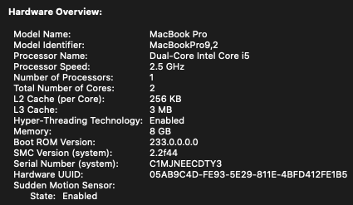

***Software:*** 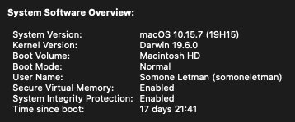

***Network Configurations:*** 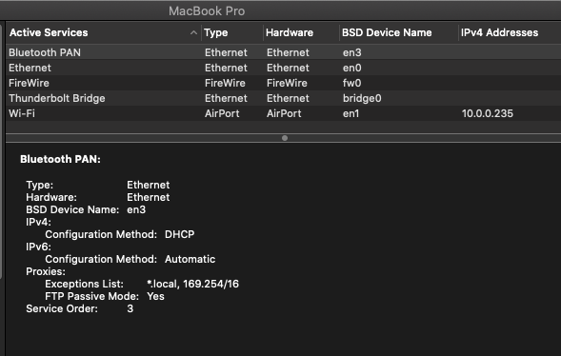

***Analyze the System:*** The system I will testing on is a 2012 Macbook Pro with MacOS Catalina.

* 1. ***You are to test an application of one of your clients below to see the response time of the end user (1 user) & document it.***
     1. After running a query for a specific flight, the results were as follows: 45000ms to complete and load all available flights. 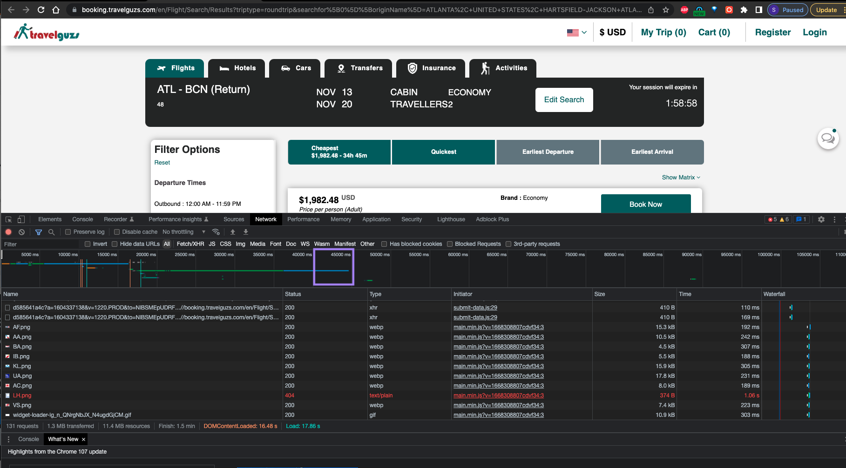

Client 2: **BlazeElectronics** is a Tech Electronics Implementation project.

Application Website- [STORE (demoblaze.com)](https://www.demoblaze.com/)

1. **Which Test(s) are you going to run for this application & why?**
   1. I will be running a Usability test on this application because I would like to focus testing on an end user’s experiences such as the following: ease of use, flexibility of application to handle controls, and ability of the application to meet its objectives.
2. **You are to create 3 test scenarios and 2 Usability test cases per scenario for an application of your choosing. You are to track this in Jira.** 
   1. View attached Excel document.
3. **Track bugs/defects in Jira & provide a screenshot.**
   1. Bug tracked: BlazeElectronics Contact Forms not Returning Confirmation Email to Users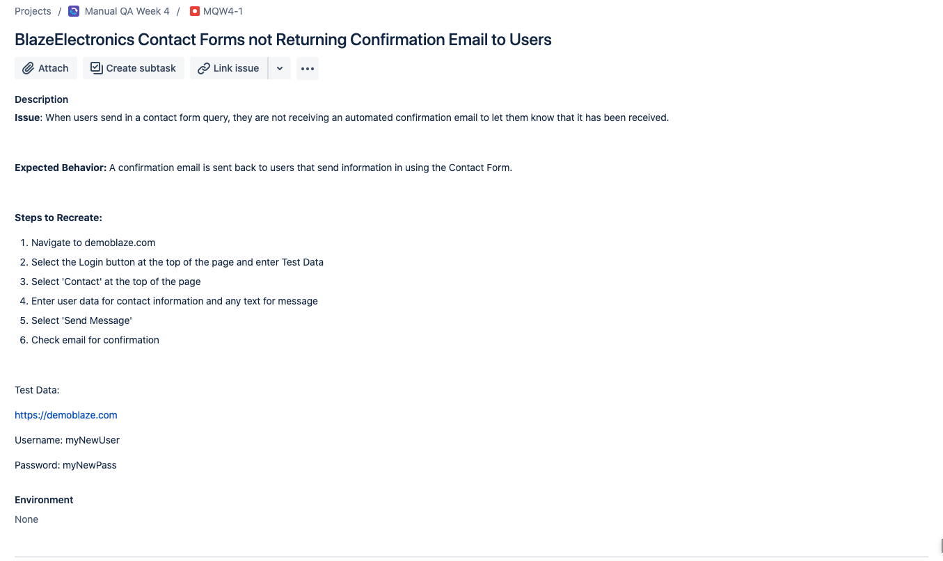

Client 3: Budget Bestie Salesforce Application

Budget Bestie Salesforce Application – No link is needed as this is an internal application

1. **Which Test(s) are you going to run for this application & why?**
   1. I will be performing a Security test on this application because there are several features that are security based that I would like to ensure are working properly on my application.
2. **Conduct Testing & document your actual results within your Test cases.**
   1. *You are to conduct security testing on the Application level within your Salesforce Development Application & document your actual results.*
3. **You are to conduct security testing on one of your clients in the UI Layer. You are to create 3 test scenarios and 2 test cases per test scenario then you are to run your tests & document your actual results**.
   1. View attached excel file.
4. **Track bugs/defects in Jira & provide a screenshot.**
   1. No bugs were found during testing at this time.